# SHIVAM KUMAR JHA

RA2411056010039

# Level 3 Practice Programs

Q1)Write a LeapYear program that takes a year as input and outputs the Year is a Leap Year or not a Leap Year.

CODE:

import java.util.Scanner;

public class Leapyear{

public static void main(String[] args){

Scanner sc=new Scanner(System.in);

int year;

System.out.print("ENTER THE YEAR");

year=sc.nextInt();

if(year>=1582){

if((year%400==0) || ((year%4==0) && (year%100 !=0 ))){

System.out.printf(" %d IT IS THE LEAP YEAR",year);

}else{

System.out.printf("%d IT IS NOT THE LEAP YEAR ",year);

}

}else{

System.out.print("ENTER YEAR GREATER THAN 1582");

}

}

}

OUTPUT:

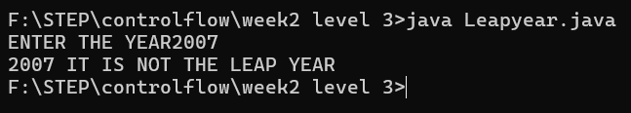

Q2) Rewrite program 1 to determine Leap Year with single if condition using logical and ***&&*** and or ***||*** operators

CODE:

import java.util.Scanner;

public class Leapyear2{

public static void main(String[] args){

Scanner sc=new Scanner(System.in);

int year;

System.out.print("ENTER THE YEAR");

year=sc.nextInt();

if(year>=1582){

if((year%400==0) || ((year%4==0) && (year%100 !=0 ))){

System.out.printf(" %d IT IS THE LEAP YEAR",year);

}else{

System.out.printf("%d IT IS NOT THE LEAP YEAR ",year);

}

}else{

System.out.print("ENTER YEAR GREATER THAN 1582");

}

}

}

OUTPUT:



Q3) Write a program to input marks and 3 subjects physics, chemistry and maths. Compute the percentage and then calculate the grade as per the following guidelines

CODE:

import java.util.Scanner;

public class StudentGrade {

public static void main(String[] args) {

Scanner sc = new Scanner(System.in);

System.out.print("Enter Physics marks: ");

int physics = sc.nextInt();

System.out.print("Enter Chemistry marks: ");

int chemistry = sc.nextInt();

System.out.print("Enter Maths marks: ");

int maths = sc.nextInt();

double average = (physics + chemistry + maths) / 3.0;

String grade;

if (average >= 80) grade = "A (Level 4, above agency-normalized standards)";

else if (average >= 70) grade = "B (Level 3, at agency-normalized standards)";

else if (average >= 60) grade = "C (Level 2, below, but approaching standards)";

else if (average >= 50) grade = "D (Level 1, well below standards)";

else if (average >= 40) grade = "E (Level 1-, too below standards)";

else grade = "R (Remedial standards)";

System.out.println("Average Marks: " + average);

System.out.println("Grade: " + grade);

sc.close();

}

}

OUTPUT:

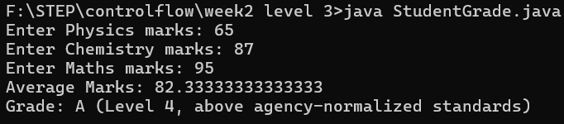

Q4) Write a Program to check if the given number is a prime number or not

CODE:

import java.util.Scanner;

public class PrimeCheck {

public static void main(String[] args) {

Scanner sc = new Scanner(System.in);

System.out.print("Enter a number: ");

int number = sc.nextInt();

boolean isPrime = true;

if (number <= 1) isPrime = false;

else {

for (int i = 2; i <= number / 2; i++) {

if (number % i == 0) {

isPrime = false;

break;

}

}

}

if (isPrime)

System.out.println(number + " is a Prime Number.");

else

System.out.println(number + " is NOT a Prime Number.");

sc.close();

}

}

OUTPUT:

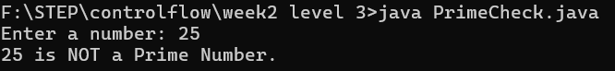

Q5)Create a program to check if a number is armstrong or not. Use the hints to show the steps clearly in the code

CODE:

import java.util.Scanner;

public class ArmstrongNumber {

public static void main(String[] args) {

Scanner sc = new Scanner(System.in);

System.out.print("Enter a number: ");

int number = sc.nextInt();

int originalNumber = number, sum = 0;

while (originalNumber != 0) {

int digit = originalNumber % 10;

sum += digit * digit * digit;

originalNumber /= 10;

}

if (sum == number)

System.out.println(number + " is an Armstrong number.");

else

System.out.println(number + " is NOT an Armstrong number.");

sc.close();

}

}

OUTPUT:



Q6) Create a program to count the number of digits in an integer.

CODE:

import java.util.Scanner;

public class CountDigits {

public static void main(String[] args) {

Scanner sc = new Scanner(System.in);

System.out.print("Enter a number: ");

int number = sc.nextInt();

int count = 0;

while (number != 0) {

number /= 10;

count++;

}

System.out.println("Number of digits: " + count);

sc.close();

}

}

OUTPUT:

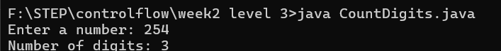

Q7) Create a program to find the BMI of a person

CODE:

import java.util.Scanner;

public class BMICalculator {

public static void main(String[] args) {

Scanner sc = new Scanner(System.in);

System.out.print("Enter weight (kg): ");

double weight = sc.nextDouble();

System.out.print("Enter height (cm): ");

double height = sc.nextDouble();

height = height / 100; // Convert cm to meters

double bmi = weight / (height * height);

System.out.printf("BMI: %.2f\n", bmi);

if (bmi < 18.4)

System.out.println("Status: Underweight");

else if (bmi <= 24.9)

System.out.println("Status: Normal");

else if (bmi <= 39.9)

System.out.println("Status: Overweight");

else

System.out.println("Status: Obese");

sc.close();

}

}

OUTPUT:

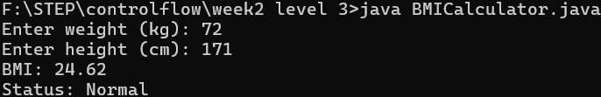

Q8) Create a program to check if a number taken from the user is a Harshad Number.

CODE:

import java.util.Scanner;

public class HarshadNumber {

public static void main(String[] args) {

Scanner sc = new Scanner(System.in);

System.out.print("Enter a number: ");

int number = sc.nextInt();

int sum = 0, temp = number;

while (temp > 0) {

sum += temp % 10;

temp /= 10;

}

if (number % sum == 0)

System.out.println(number + " is a Harshad Number.");

else

System.out.println(number + " is NOT a Harshad Number.");

sc.close();

}

}

OUTPUT:



Q9)Create a program to check if a number is an Abundant Number.

CODE:

import java.util.Scanner;

public class AbundantNumber {

public static void main(String[] args) {

Scanner sc = new Scanner(System.in);

System.out.print("Enter a number: ");

int number = sc.nextInt();

int sum = 0;

for (int i = 1; i < number; i++) {

if (number % i == 0)

sum += i;

}

if (sum > number)

System.out.println(number + " is an Abundant Number.");

else

System.out.println(number + " is NOT an Abundant Number.");

sc.close();

}

}

OUTPUT:



Q10)Write a program to create a calculator using ***switch...case***.

CODE:

import java.util.Scanner;

public class Calculator {

public static void main(String[] args) {

Scanner sc = new Scanner(System.in);

System.out.print("Enter first number: ");

double first = sc.nextDouble();

System.out.print("Enter second number: ");

double second = sc.nextDouble();

System.out.print("Enter operator (+, -, *, /): ");

String op = sc.next();

switch (op) {

case "+":

System.out.println("Result: " + (first + second));

break;

case "-":

System.out.println("Result: " + (first - second));

break;

case "*":

System.out.println("Result: " + (first * second));

break;

case "/":

if (second != 0)

System.out.println("Result: " + (first / second));

else

System.out.println("Error: Division by zero");

break;

default:

System.out.println("Invalid Operator");

}

sc.close();

}

}

OUTPUT:

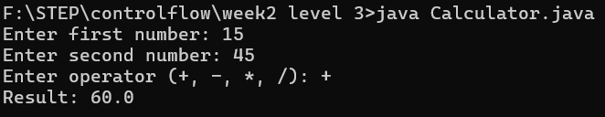

Q11)Write a program ***DayOfWeek*** that takes a date as input and prints the day of the week that the date falls on. Your program should take three command-line arguments: m (month), d (day), and y (year). For m use 1 for January, 2 for February, and so forth. For output print 0 for Sunday, 1 for Monday, 2 for Tuesday, and so forth. Use the following formulas, for the Gregorian calendar (where / denotes integer division):

CODE:

import java.util.Scanner;

public class DayOfWeek {

public static void main(String[] args) {

Scanner sc = new Scanner(System.in);

System.out.print("Enter month (1-12): ");

int m = sc.nextInt();

System.out.print("Enter day (1-31): ");

int d = sc.nextInt();

System.out.print("Enter year: ");

int y = sc.nextInt();

int y0 = y - (14 - m) / 12;

int x = y0 + y0 / 4 - y0 / 100 + y0 / 400;

int m0 = m + 12 * ((14 - m) / 12) - 2;

int d0 = (d + x + (31 * m0) / 12) % 7;

String[] days = { "Sunday", "Monday", "Tuesday", "Wednesday", "Thursday", "Friday", "Saturday" };

System.out.println("Day of the week: " + days[d0]);

sc.close();

}

}

Output:

